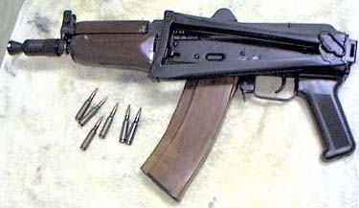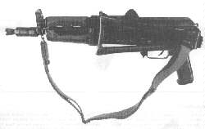
AKR
Ammo | Mag | Rng | ROF | Dam | Arm
5.45 B | 10 / 30 | 30 | 4 | 2 | x2
Description: The AKR is the standard Eastern Bloc submachine gun (except in the Czech army). The AKR (also known as the AKSU) is merely a cut-down version of the AK-74. Although a bit heavy for a submachine gun, it has good accuracy and stopping power.
Nation: USSR Weight: 4 kg
Ammunition: 5.45 B Magazine: 10 / 30
Price: $550 Availability: ( S/C )

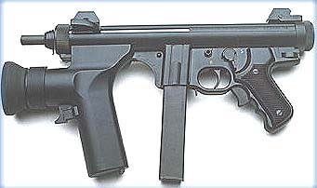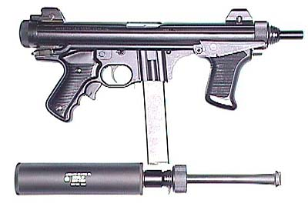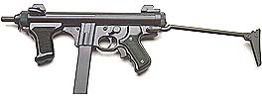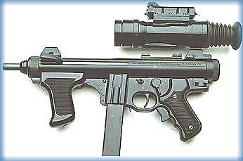
Beretta PM-12
Ammo | Mag | Rng | ROF | Dam | Arm
9mm P | 13 / 30 | 20 | 4 | 1 | x3
Description: The standard issue SMG of the Italian police and military, the PM-12 is a well crafted, well balanced weapon. It features a front and rear pistol grip, folding stock, and grip safety. The PM-12 was one of the contestants in the US Army’s Combat Vehicle Crewman Individual Weapon Competition in 1991. Although it wasn’t chosen, the PM-12 found a number of buyers in various US police departments.
Nation: Italy Weight: 3.0 kg
Ammunition: 9mm P Magazine: 13 / 30
Price: $850 Availability: ( R/S )

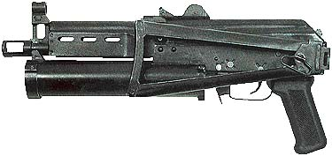
Bizon
Ammo | Mag | Rng | ROF | Dam | Arm
9mm M | 66 | 15 | 6 | 1 | X4
Description: The Bizon is a high capacity submachine gun with a folding stock to increase accuracy (range).
Nation: Russia Weight: 2.25 kg
Ammunition: 9 mm M Magazine: 66
Price: $600 Availability: ( -/S )
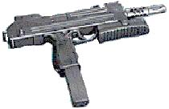
BXP
Ammo | Mag | Rng | ROF | Dam | Arm
9mm P | 30 | 18 | 5 | 1 | x2
Description: South Africa developed the BXP for use in their police force. It’s design was based after that of IMI’s popular Uzi.
Nation: South Africa Weight: 3.0 kg
Ammunition: 9mm P Magazine: 30
Price: $550 Availability: ( S/S )

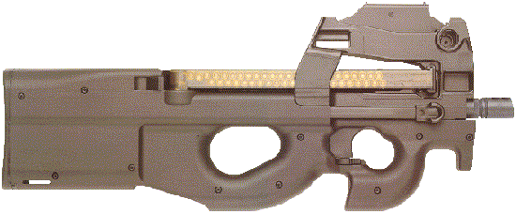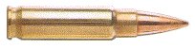
FN P90
Ammo | Mag | Rng | ROF | Dam | Arm
5.7 | 50 | 15 | 6 | 0 | ½
Description: FN created the P90 to supply troops with a weapon that could take place of both the submachine and the assault rifle. Although it is dependable, weather-proofed, high capacity, and has a unique round, the P90 fell short of its users expectations. The P90 uses the 5.7mm round which penetrates very well but does little damage. Another downside is that with the outbreak of the war, like the HK G11, ammunition is exceedingly scarce. Unlike the G11, this ammunition can be reloaded – with the appropriate skill (Gunsmith) tools. It comes with an integral laser sight (on the lip under the barrel) and a cleaning kit in the stock. The larger trigger guard allows individuals to fire with gloves on.
Nation: Belgium Weight: 2.5 kg
Ammunition: 5.7mm Magazine: 50
Price: $1100 Availability: ( S/- )

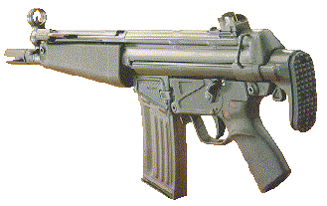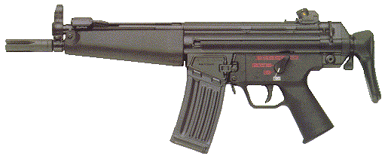
HK 53
Ammo | Mag | Rng | ROF | Dam | Arm
5.56N | 20 | 35 | 4 | 2 | -
Description: A 5.56 N firing port weapon, designed to be the big bad brother of the ever popular MP-5.
Nation: West Germany Weight: 3.25 kg
Ammunition: 5.56 N Magazine: 20
Price: $950 Availability: ( R/- )

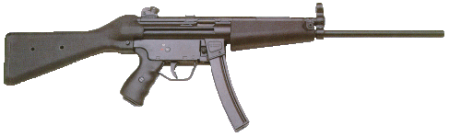
HK 94
Ammo | Mag | Rng | ROF | Dam | Arm
9mm P | 30 | 30 | 4 | 1 | x2
Description: The HK 94 is an extremely well made weapon. With single, burst and full auto capabilities, long barrel for increased range, high capacity magazines, and an easy to find ammunition it is a good choice for characters that like to travel light.
Nation: 9mm P Weight: 3 kg
Ammunition: 9mm P Magazine: 30
Price: $800 Availability: ( C/S )

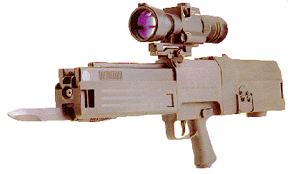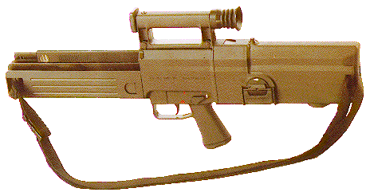
HK G11
Ammo | Mag | Rng | ROF | Dam | Arm
4.7mm cls | 50 | 40 | 5 | 2 | ½
Description: A weapon of radical design and great effectiveness, the G11 replaced the G3 as the standard assault rifle and the Uzi as the standard submachine gun of the West German army. It’s unique nature is fully described in the Equipment List.
Currently, although the weapon is not uncommon, ammunition for it is increasingly rare, and most German soldiers have equipped themselves with other weapons due to this fact.
Nation: West Germany Weight: 4 kg
Ammunition: 4.7mm cls Magazine: 50
Price: $900 Availability: ( S/R )

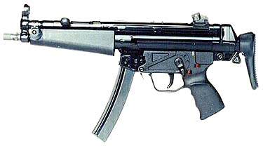
HK MP5
Ammo | Mag | Rng | ROF | Dam | Arm
9mm P | 30 | 25 | 4 | 1 | x2
Description: The standard SMG fo the West Germany territorial troops and police.
Nation: West Germany Weight: 3.0 kg
Ammunition: 9mm P Magazine: 30
Price: $700 Availability: ( C/S )

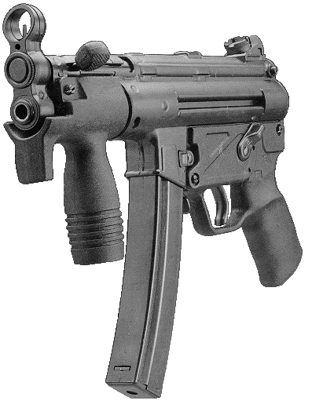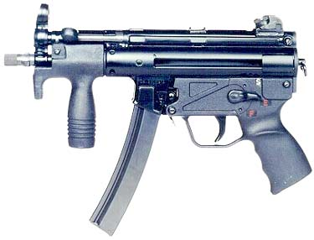
HK MP5K
Ammo | Mag | Rng | ROF | Dam | Arm
9mm P | 15 / 30 | 20 | 4 | 1 | x2
Description: A shortened version of the MP-5. The MP5K has found it’s niche in covert operations and security forces. The high capacity magazine, size, and reliability make it an excellent weapon.
Nation: West Germany Weight: 2.1 kg
Ammunition: 9mm P Magazine: 15 / 30
Price: $750 Availability: ( R/S )

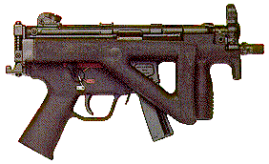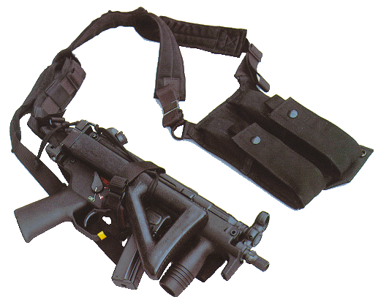
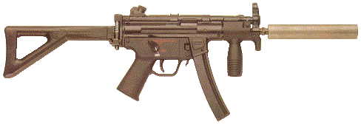
HK MP5K-PDW
Ammo | Mag | Rng | ROF | Dam | Arm
9mm P | 30 | 20 | 4 | 1 | x2
Description: This is a security version of the MP5K. Folding stock and dual hand holds make the PDW accurate. (see rules for folding stocks).
Nation: West Germany Weight: 2.8 kg
Ammunition: 9mm P Magazine: 30
Price: $780 Availability: ( S/R )

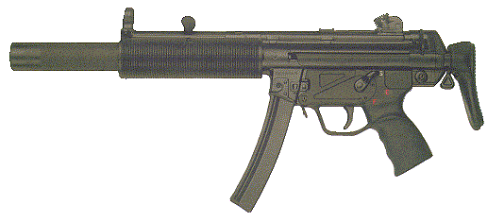
HK MP5SD
Ammo | Mag | Rng | ROF | Dam | Arm
9mm P | 30 | 20 | 4 | 1 | x2
Description: A variant of the MP-5 fitted with an integral suppressor. Any attempt to spot a character using this weapon gets an automatic –40% to their RCN roll.
Nation: West Germany Weight: 3 kg
Ammunition: 9mm P Magazine: 30
Price: $1500 Availability: ( S/R )

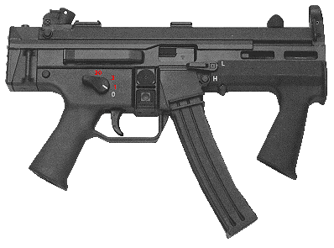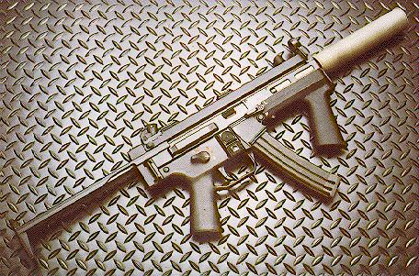
HK SMG II
Ammo | Mag | Rng | ROF | Dam | Arm
9mm P | 30 | 25 | 5 | 1 | x2
Description: SMG II was designed in 1984 for a classified end-user who was well familiar with the advantages and shortcomings of the entire MP5-series of weapons. The result of HK's development and user feedback was a synthesis of some of the more desirable features within the MP5 system, several features from other weapons such as the UZI, and some new developments unique to the SMG II.
Nation: West Germany Weight: 3.0
Ammunition: 9mm P Magazine: 30
Price: $1,100 Availability: ( R/- )

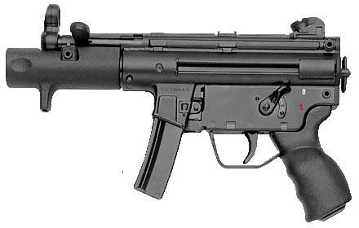
HK SP89
Ammo | Mag | Rng | ROF | Dam | Arm
9mm P | 15 / 30 | 15 | 6 | 1 | x2
Description: The 2 kilogram featherweight called the SP89 has also made it’s mark in the security and covert operations arenas.
Nation: West Germany Weight: 2 kg
Ammunition: 9mm P Magazine: 15 / 30
Price: $600 Availability: ( S/- )

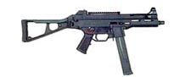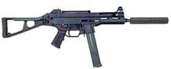
H&K UMP45
Ammo | Mag | Rng | ROF | Dam | Arm
.45 ACP | 25 | 20 | 4 | 2 | x3
Description: As a .45 caliber, the demand for power has been appeased in the submachine gun family. HK’s Universal Machine Pistol has everything the MP-5 has with a bit more bite.
Nation: West Germany Weight: 3.0 kg
Ammunition: .45 ACP Magazine: 25
Price: $1000 Availability: ( S/- )

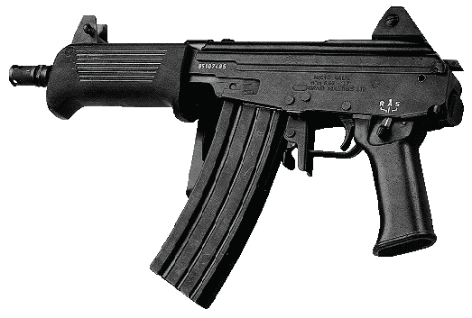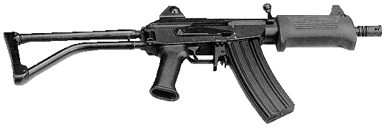
IMI Micro Galil
Ammo | Mag | Rng | ROF | Dam | Arm
5.56 N | 20 | 30 | 5 | 2 | -
Description: A cut down version of the Galil ARM. The Micro Galil definitely continues to carry on the IMI reputation for dependability. Range goes up to 35 when stock is used.
Nation: Israel Weight: 3.25 kg
Ammunition: 5.56 N Magazine: 20
Price: $750 Availability: ( S- )

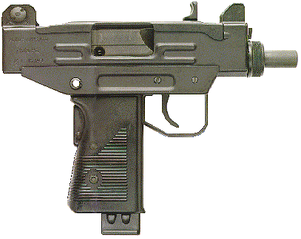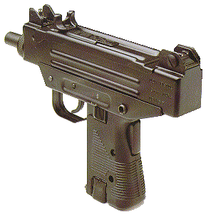
IMI Micro Uzi
Ammo | Mag | Rng | ROF | Dam | Arm
.45 ACP  9mm P | 10  15 | 10  15 | 7  10 | 2  1 | x3  x2
Description: The rapid firing Micro has found an irreplaceable niche in the Secret Service, Special Forces, and many others. Compact size and high rate of fire….what else matters?
Nation: Israel Weight: 1.7 kg
Ammunition: 9mm P Magazine: 15 / 30
Price: $800 Availability: ( S/- )

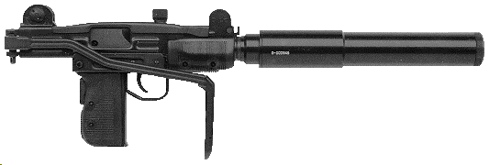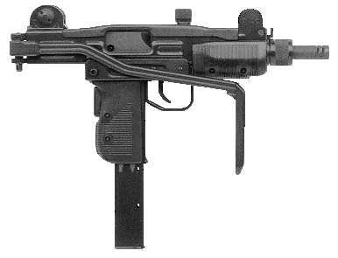
IMI Mini-Uzi
Ammo | Mag | Rng | ROF | Dam | Arm
9mm P | 15 / 30 | 20 | 10 | 1 | x2
Description: The mini-uzi is a compact, quick version of the Uzi. Larger than the pistol sized micro-uzi, the Mini has a longer range and is popular with vehicle crews.
Nation: Israel Weight: 2.75 kg
Ammunition: 9mm P Magazine: 15 / 30
Price: $900 Availability: ( C/S )

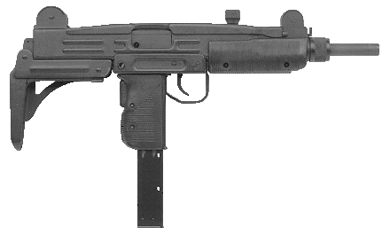
IMI Uzi
Ammo | Mag | Rng | ROF | Dam | Arm
9mm P | 15 / 30 | 30 | 5 | 1 | x2
Description: The Israeli made Uzi is a common SMG worldwide. Once the standard SMG of the West German army, it is now returning to services as ammunition for the G11 becomes scarce. Police and other government agencies, such as the United States Secret Service and Federal Marshal Services commonly use the Uzi.
Nation: Israel Weight: 4 kg
Ammunition: 9mm P Magazine: 15 / 30
Price: $800 Availability: ( V/C )

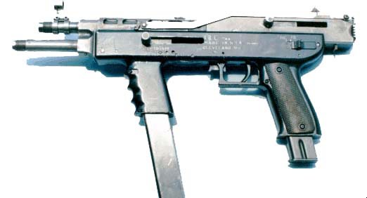
I.M. Model 1 & 2
Ammo | Mag | Rng | ROF | Dam | Arm
9mm P | 2 – 20rnd or  2 – 30rnd | 25 | 10 | 1 | x2
Description: The Model 2 is the perfected version of I.M’s Model 1. This dual-barreled submachine gun with dual magazine feeds. The weapon feeds 9mm ammunition from both magazines in turn through the corresponding barrel. This allows high capacity rate of fire for longer periods of time. I.M. (Ion Mihaita) produced these weapons in the early 1990’s so they did not have time to be even considered for the military before the War started.
Nation: United States Weight: 6.5 kg
Ammunition: 9mmP Magazine: 2x20 or 2x30
Price: $1100 Availability: ( -/- )

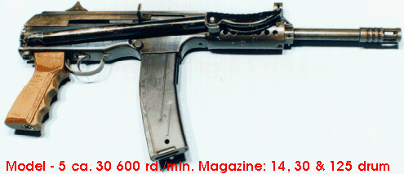
I.M. Model 5
Ammo | Mag | Rng | ROF | Dam | Arm
.30 Cal | 20 | 30 | 4 | 2 | x2
Description: Similar to the Mini-14, the Model 5 uses the 30 caliber round. The weapon is well made, accurate and hits hard.
Nation: United States Weight: 3.5 kg
Ammunition: .30 cal Magazine: 20
Price: $950 Availability: ( -/- )

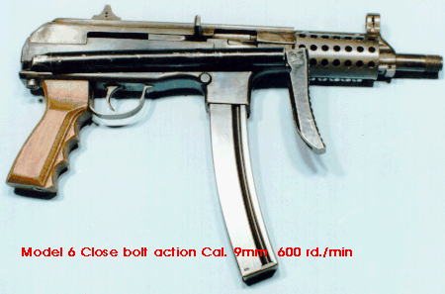
I.M. Model 6
Ammo | Mag | Rng | ROF | Dam | Arm
9mm P | 30 | 20 | 6 | 1 | X2
Description: The Model 6 is a smaller version of the Model 5. More practical as a submachine gun than the Model 5, the Model 6 has a smaller round (9mm P) and higher rate of fire.
Nation: United States Weight: 2.75 kg
Ammunition: 9mm P Magazine: 30
Price: $850 Availability: ( -/- )

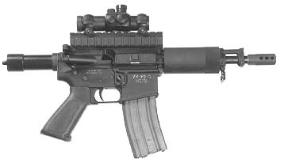
M231
Ammo | Mag | Rng | ROF | Dam | Arm
5.56 N | 20 / 30 | 15 | 5 | 2 | -
Description: The standard firing port weapon on the M2 Bradley AFV, this weapon is a satisfactory vehicle weapon for suppressive fire, but a mediocre submachine gun. Nevertheless, with large numbers of Bradleys no longer operational it was inevitable that the M231 would be dismounted and used in large numbers. Folding stock can be added increasing the range to 20.
Nation: United States Weight: 4 kg
Ammunition: 5.56 N Magazine: 20 / 30
Price: $550 Availability: ( V/C )

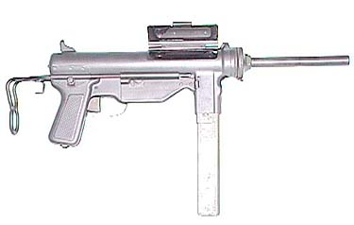
M3A1 Grease Gun
Ammo | Mag | Rng | ROF | Dam | Arm
.45 ACP | 10 / 30 | 15 | 4 | 2 | x3
Description: Know as the “Grease Gun” because of its resemblance to an automotive serving tool, the M3A1 was a cheap easily manufactured and fairly reliable WWII vintage American SMG. It was used primarily by vehicle crews (usually in tanks) until well into the 1990s.
Nation: United States Weight: 3.47 kg
Ammunition: .45 ACP Magazine: 10 / 30
Price: $450 Availability: ( C/S )

